Week 3:

|  |  |
| --- | --- |
| Topic | CSS3 (Cascading Style Sheets3) |
| Practical Exercise | Week 3 |

Question 1

In this exercise, you will alter two HTML pages and apply various styles to improve the appearance of your pages. You will apply various Selector styles throughout this part-but still no scripting is needed. Home.html

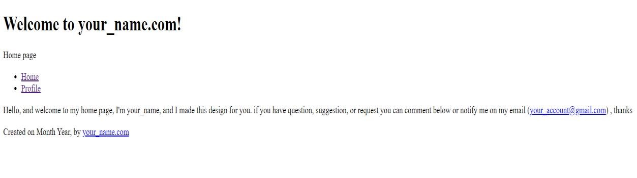

1. Alter the home.html page to include the <p> below the <nav> element

|  |
| --- |
| <p id="message">Hello, and welcome to my home page,  I'm your_fullname, and I made this design for you. if you have question, suggestion, or request you can comment below or notify me on my email  (<a href = "your_account@gmail.com">your_account@gmail.com</a>)  , thanks  </p> |

# CSS Syntax Overview

The CSS has a set of rules for defining the particular style of an element. That should be followed to successfully apply the CSS style on the HTML document. The CSS rules have four essential parts:

* Selector
* Declaration
* Property
* Value

# Selector

The CSS selector is a keyword used to point the CSS style to the HTML element. The selector can use the element name, class, id, and more. Refer to the Types of Selector section for more details.

# Declaration

The CSS declaration block consists of open and close curly buckets. Inside each of these curly buckets, there are one or more declarations.

Each declaration contains property and value and is separated by the colon. The declaration should end with a semicolon.

# Property

The CSS property is an attribute of the HTML element that is defined by the selector. In a web browser, all of the element attributes are converted to CSS properties e.g. colour, background-colour, etc.

# Value

The CSS value is a value set for CSS property e.g. colour property has a value of white. See the example image for the <p> tag element:

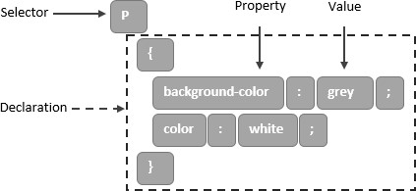

# Types of CSS Selectors

This section will explain alternative ways of defining the selector in CSS. Therefore, the following examples are the most commonly used type of selectors:

* Element Selector
* ID Selector
* Class Selector
* Universal Selector
* Grouping Selector

## Element Selector

Like the common examples above, the CSS selector can use the HTML element name. For example, h1, p, body, etc. to select a specific element.

## ID Selector

The CSS selector can use the ID attribute of an HTML element to select a specific element. To use the ID attribute as a selector, put a hash (#) character at the beginning of the selector to define the ID of the element.

Here is the example. Add this code in home.css:

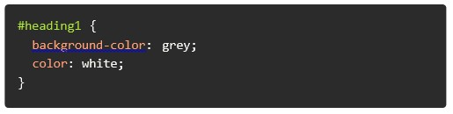

Add an ID attribute on h1 tag in home.html:

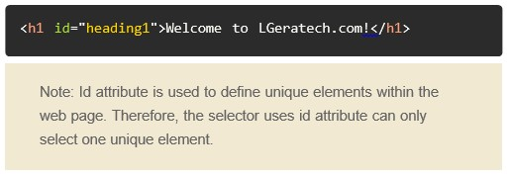

## Class Selector

The CSS selector can use the class attribute of an HTML element to select a specific element. Put a period (.) character at the beginning of the selector to define the class of the element. Here is the example. Add this code in home.css:

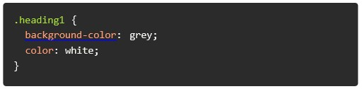

Add an ID attribute on h1 tag in home.html:



You can also add an element name before the period (.) character to be more specific with selecting the class attribute of the element:

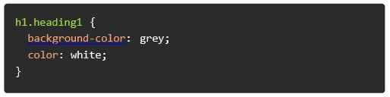

## Universal Selector

The CSS selector can use the asterisk (*) character to select all of the HTML elements. Here is an example. Add this code in home.css:

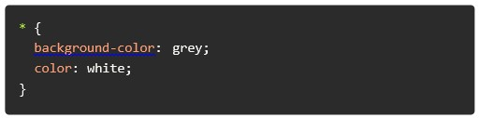

## Grouping Selector

The CSS selector can use multiple-element names at the same time. Let’s combine all of the HTML elements that have the same style definition.

Let’s take a look at the below without the grouping selector, and all of the elements with the same style:

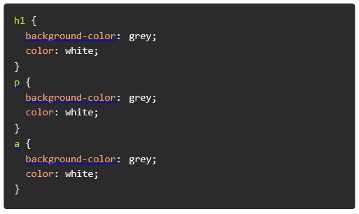

However, when we use the grouping selector, it will minimise the size of the code in the CSS file, add this code in home.css:

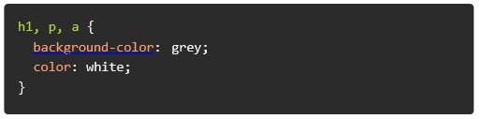

Note: Separate each element with a comma like in the example above; you can use

a grouping selector to combine the element selector with the same style definition.

It will minimise the size of the code.

# Comments

CSS uses the comment block to allow the developers to add notes to their codes. However, you can also apply the comment to the unnecessary codes. Therefore, the browser will not interpret it.

The Comment block format starts with /* and ends with */ and can also cover multiple lines:

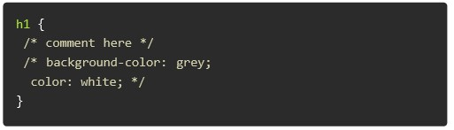

# More CSS Style Implementation

Now we’ve done the essential part of CSS. Let’s take a look at some additional CSS Style examples to make our home page more attractive and our design more user-friendly.

As you can see below, the home page has a much better design compared to the previous home page example:

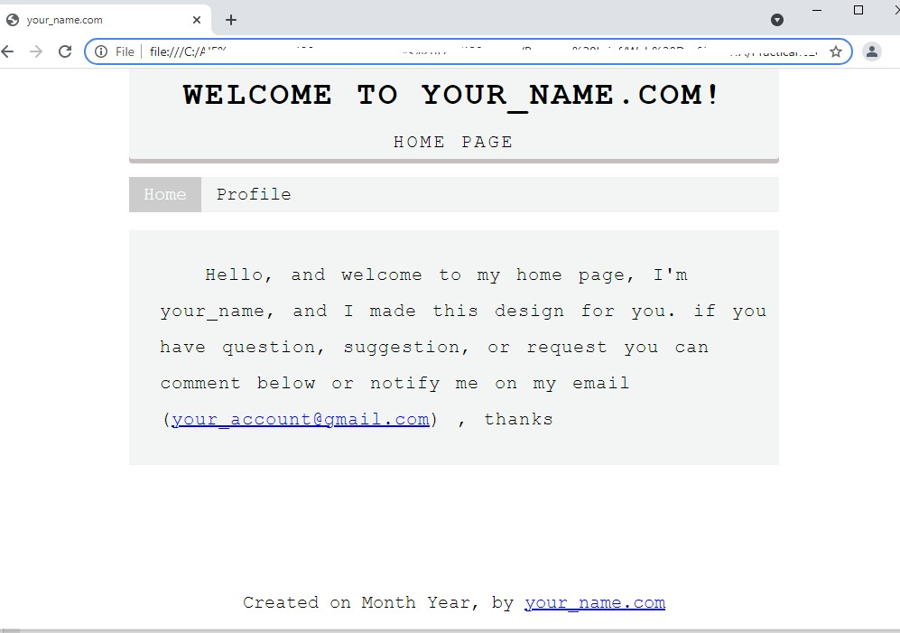

Continue reading below for more details about the design.

## Home Page Implementation

Change the home.html into the code below:

## CSS Implementation

Create style.css together with home.html and read the comments below to implement each property of the styling by entering the details:

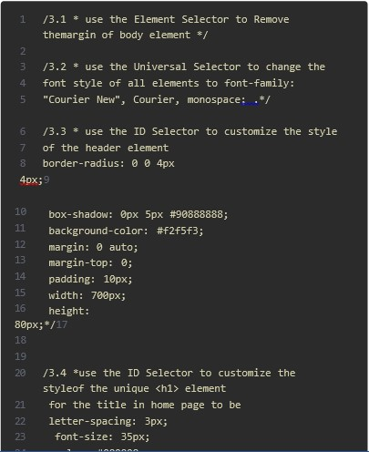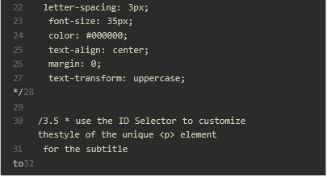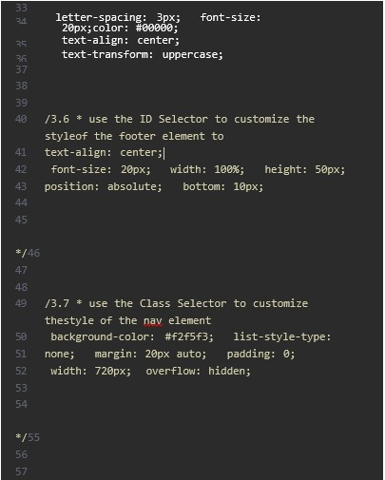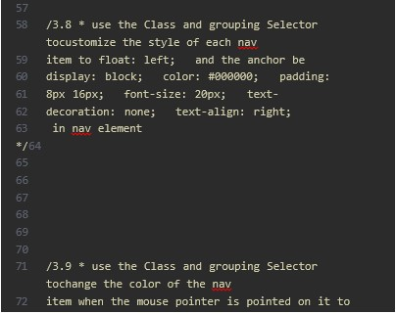

Question 2: UX/UI design quiz

2.1 What of the following are not the elements of design?

1. Line
2. Shape
3. Colour
4. Device

2.2 Which lines creates a feeling of rest or calm?

1. Horizontal
2. Vertical
3. Diagonal

2.3 ………………………….. shapes are freeform, often asymmetrical and irregular. a. Organic

1. Inorganic
2. Geometric

2.4 …………………………. states that when objects move in the same direction, we tend to see them as a unit.

1. Law of common fate
2. Law of proximity
3. Law of good continuation

Week 4:

|  |  |
| --- | --- |
| Topic | HTML /JAVASCRIPT AND ADOBE PHOTOSHOP |
| Practical Exercise | Week 4 |

Question 1:

Q 1.1.

Create a table with rows that have alternating colours as below. Also note the headings should be the same.

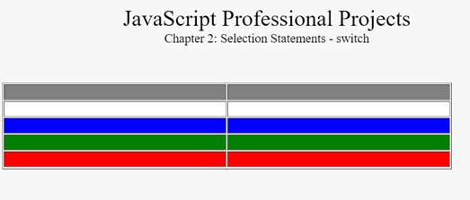

Q 1.2 Create the Output below using HTML/Javascript

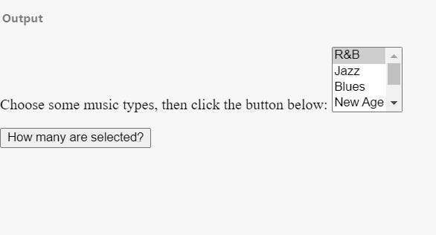

Hint: For Q1.2 - A for statement looks as follows:

|  |
| --- |
| for ([initialExpression]; [conditionExpression]; [incrementExpression])  statement |

The function contains a for statement that counts the number of selected options in a scrolling list

(a [<select>](https://developer.mozilla.org/en-US/docs/Web/HTML/Element/select) element that allows multiple selections). The for statement declares the variable i and initializes it to 0. It checks that i is less than the number of options in the <select> element, performs the succeeding if statement, and increments i by after each pass through the loop

Question 2:

Adobe Photoshop quiz

Choose appropriate answer

|  |  |
| --- | --- |
| Question | Options |
| Lesson 1 – Get to know Photoshop | |
| 1.What is the quickest way to open an image | 1. File>Open 2. File>Image 3. Image>Open 4. Edit>Open |
| 2. The Options Bar is an important bar because | 1. it displays file size and dimension 2. it displays the options for the selected tool 3. it tells you when to save 4. it always shows the same settings |

|  |  |
| --- | --- |
| 3. What does the Hand tool do? | 1. Changes between open documents 2. Zooms in and out 3. Adds a hand graphic to your design 4. Allows you to pan around a large or zoomed-in image |
| 4. The History panel displays what information? | 1. Shows you visual inspiration based on history 2. Lists what tools should be used on the image. 3. Lists how many times a document has been opened. 4. Lists your actions whilst a document has been open |
| 5. What file format enables you to open the file in  Photoshop and continue working with all the layers? | 1. .png 2. .psd 3. .jpeg 4. .layers |
| Lesson 2 – Change the Image Size | |
| 1. When you select Image>Image Size what happens? | 1. You are able to change the width,   height and resolution of your whole document   1. You are able to change the width, height and resolution of a selected layer only 2. Your image is resized to 100 pixels 3. Your image’s resolution is changed to 100 pixels per inch. |
| 2. What does image resolution mean in Photoshop? | 1. The resolution of the screen you are using to work on 2. The image quality is very high 3. The number of pixels per square inch in your image. 4. The image quality is too low |
| 3. How do you avoid deleting cropped pixels when using the Crop tool? | a. Uncheck ‘Delete Cropped Pixels’ in the Options bar before cropping. b. You cannot avoid deleting cropped pixels.   1. Use the Canvas size instead 2. Use the Image Size instead |
| 4. In the Canvas size pop-up box, what does the Relative function do? | 1. It centres the image to the canvas 2. It adds a specified amount of pixels to the total height or width. 3. It will align all layers to the top of the canvas 4. It resizes you image relative to other open documents |

|  |  |
| --- | --- |
| 5. How can you set a canvas to extend in specific directions only? | 1. Select the direction from the   Direction drop-down menu   1. Set the direction using the arrows in the Anchor area of the Image size window. 2. You cannot extend the canvas 3. The canvas can only extend outwards from the centre |
| Lesson 3 – Work with Layers | |
| 1. What is a layer’s main function | 1. To keep contents separate from one another 2. To make objects individually editable 3. To be able to show and hide individual objects 4. All of the above |
| 2. How do you create a New layer? | 1. File>New 2. Edit>New Layer 3. In the Layers panel, click the New   Layer Icon   1. In the Layers panel, click the Eye icon. |
| 3. What does Edit> Free Transform do? | 1. Automatically rotates a layer 90 degrees 2. Enables you to resize a layer 3. Enables you to add perspective to an image 4. Converts a layer to black & white |
| 4. How do you add an image into a design? | 1. Edit>Insert Image 2. Edit>New Image 3. File>Paste New 4. File>Place Embedded |
| 5. What makes a background layer different to other layers | 1. It cannot have transparency 2. It cannot be edited 3. It cannot be duplicated 4. It cannot be renamed |
| Lesson 4 – Adjust the image quality | |
| 1. What can’t you do when adjusting Brightness and Contrast using the Image>Adjustments menu? | 1. Adjust colours separately 2. Adjust overall brightness 3. Adjust overall contrast 4. Adjust individual layers only |
| 2. What does Vibrance refer to? | a. How much pure red a colour has in it  b The intensity of the colour   1. How desaturated the colours are 2. The tonal difference between colours. |

|  |  |
| --- | --- |
| 3. What slider in the Hue Saturation adjustment changes the actual colour of the image | 1. Hue slider 2. Saturation slider 3. Lightness slider 4. Contrast slider |
| 4.How is an Adjustment Layer different to using the Image>Adjustments? | 1. It shows as a specific layer on the   Layer’s panel   1. You add an adjustment layer on the Layers panel 2. An adjustment layer’s adjustment can be edited once it’s applied d. All of the above |
| Lesson 5 – Making Selections |  |
| 1. Once a selection is made, how do you deselect it? | 1. Layers>Undo Selection 2. Edit>Deselect 3. Select>Deselect 4. Image>Undo Selection |
| 2. The Quick Selection tool creates selections when you | 1. clicking once in an image area 2. click and drag in an area you want to select 3. drag along an edge 4. click outside of the image area |
| 3. To fine tune a selection you use | 1. Select> Select and Mask 2. Select>Refine Selection 3. Layer>Refine Layer 4. Select>Selection Options |
| Lesson 6 – Retouch Images | |
| 1. The Spot Healing brush is used to | a. Smooth skin tone b Remove small unwanted spots or blemishes   1. Change colour of spots in pattern 2. Correct bad lighting |
| 2. What tool copies areas and paints them elsewhere | 1. Repeat tool 2. Copy tool 3. Clone Stamp tool 4. Pattern Stamp tool |
| 3. The content aware function uses an unwanted objects’_____________ to fill in the space when it’s deleted. | 1. surroundings 2. width and height 3. colour 4. tonal range |
| Lesson 7 – Use Colour | |
| 1. Which one is not a valid Brush option? | 1. Resolution 2. Size 3. Colour 4. Opacity |
| 2. How do you set the Foreground and Background colours to the default Black and White | 1. Edit>Default Colors 2. Edit>Revert to default |
|  | 1. Press Ctrl+D /Cmd+D on the keyboard 2. Press D on the keyboard |
| 3. What panel contains small squares of colour to choose from? | 1. Color panel 2. Adjustments panel 3. Properties panel 4. Swatches panel |
| Lesson 8 – Adding Text and Shapes |  |
| 1. What tool is used to create standard text in Photoshop? | 1. Type tool 2. Horizontal Type tool 3. Display Type tool 4. Text tool |
| 2. When you Type on a selected Layer, what will happen? | 1. A new blank layer is created 2. The text is types directly on the selected layer. 3. A Type Layer is created above the selected layer   d.A Type layer is created below the selected layer |
| 3. What panel has options for shapes to be edited | 1. Properties panel 2. Shape panel 3. Options panel 4. Shape Layer panel |
| 4. What is a custom shape? | 1. A shape you have drawn yourself 2. A preset shape that you can   choose to insert from a list of custom shapes   1. A shape that is easily edited 2. Any shape is called a custom shape |

APPENDIX

1. Introduction

Welcome to the Website Design and Development Subject. You will learn the fundamental concepts of using HTML/CSS/Javascript. This subject is offered to all IT Systems Dev students /Web Dev (and other stream (SW/Web Dev)).

Use the Subject Pacer (provided in the Student Portal) to help you plan your studies. This will help you to stay on track to complete the subject within the planned timeframe. This schedule will also be used by the mentors when they plan workshops and/or online sessions to review content.

1. Resources

Several useful resources can be downloaded from the Student Portal:

* The Website Design and Development material
* A second source on Microsoft source and other links as per pacer.
* The Practical Guide (for weekly practical exercises)
* Practical Projects
* Additional resources (e.g. videos) could also be made available in the Student Portal

1. Assessments

a) Weekly practical exercises:

* + This subject is presented using a problem-based approach. This ensures that students work on practical exercises and projects throughout the subject. The practical exercises to be completed each week are set out in the Practical Guide, and are compulsory. The subject mentor will discuss solutions and examples of student work during contact sessions to ensure that everyone knows how to solve the problems and can learn from their progress.

b) Practical projects:

* + All students completing this subject must submit 2 integrated practical projects after completing the subject.